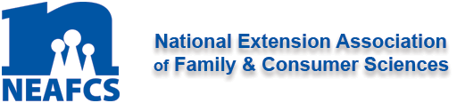

North Carolina Extension Association of Family & Consumer Sciences

Business Meeting
July 29, 2020

- Welcome & Call to Order Tracy Davis, President

- Thought for the Day Sonya Patterson, President-Elect

- Minutes Eleanor Frederick, Secretary

- Treasurer’s Report Toi Degree, Treasurer

- Registration Report Carmen Long, State Meeting Chair
(Host District)

- Annual Reports 2019-2020 Sonya Patterson, President-Elect

Plan of Work Updates:
Professional Development & Recognition Emily Troutman
Member Resources & Historian Meleah Evers
Public Affairs Olivia Patchel

District Presidents:
Northeast Dominque Simon
Southeast Kelly Tyndall
North Central Carmen Long
South Central Alyssa Anderson
West Renay Knapp

Standing Committees:
By-Laws/Policies & Procedures Sonya Patterson
Budget Toi Degree
Historian Meleah Evers
Nominating Hayley Cowell
Annual Meeting & Retiree Event Carmen Long
Website Cathy Hohenstein

- Association Meeting Reports

Joint Councils of Extension Professionals (JCEP)
North Carolina Tracy Davis
National Emily Troutman
Public Issues Leadership Development (PILD) Sonya Patterson

- New Business (* Action Item)

Slate of Officers 2020-2021* Hayley Cowell, Nominating Chair
2020 Budget* Toi Degree, Budget Chair
By-Laws/Policies & Procedures* Sonya Patterson, By-Laws Chair

- Unfinished Business

- Announcements

State & National Meetings:

2020 NEAFCS Annual Session September 14-16 Virtual
Early Bird Deadline 8/23/20

2021 NCEAFCS State Meeting August 2021 Northeast District

2021 NEAFCS Annual Session November 2-5 Grand Rapids, MI

2022 NEAFCS Annual Session September 12-15 Raleigh, NC

- Adjourn

