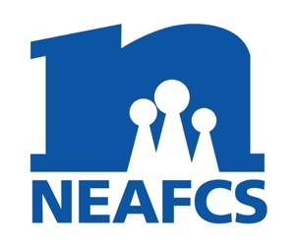
North Carolina Extension Association of Family and Consumer Sciences
District President
Annual Report

District: Northeast Month/Year: Aug. 2022

District Meeting Dates & Locations:

The Fall NED meeting was held at the Chowan County Extension Center on December 13, 2021, hosted by Mary Morris. Members in attendance were Mary Morris, EB Odom, Ellen Owens, Olivia Patchel, Louise Hinsley, Tanisha Armstrong, Catie Jo Black, Regina Mosely and Liz Baker.

Slate of officers was installed as follows:
Slate of officers for 2021-2022
President-Ellen Owens
President Elect-Catie Jo Black
VP Public Affairs- Liz Baker
VP Professional Development & Recognition -Regina Moseley
VP Member Resources & Historian - Louise Hinsley
Secretary-Olivia Patchel
Treasurer-Mary Morris
Immediate Past President/ Parliamentarian/ Counselor-EB Odom
Retiree Rep- Jewel Winslow

The Spring meeting was held in Dare County on May 20, 2022, hosted by Dee Furlough. Members present included: Dee Furlough, Mary Morris, Ellen Owens, EB Odom, Regina Mosely, Mary Morris, and Liz Baker.

Educational Programs, Tours, Professional Development activities:

Members held a holiday cookie swap at the December meeting and shared homemade cookies and recipes. Members also participated in a holiday ornament workshop.

Members held a teacup raffle to raise additional operating funds at the May meeting. Members participated in a workshop conducted by former member Rosie Rankin and colleague Shirley Parker from Outer Banks Inner Journey. Agents learned how to de-stress and were given a few excellent relaxation strategies.

Other district activities:
The membership voted to add the new Retired Membership Liason to our slate of officers. Louise Hinsley is currently serving in this role.

ANNUAL REPORT SUBMITTED BY: Ellen Owens

