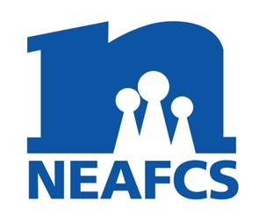
North Carolina Extension Association of Family and Consumer Sciences
District President
Annual Report

District: South Central Month/Year: May/2022

District Meeting Dates & Locations:
May 26, 2022 at the Anson County Extension Office in Wadesboro, NC.
501 McLaurin St, Wadesboro, NC 28170

Educational Programs, Tours, Professional Development activities:
-When providing NC JCEP Report, I provided education on what JCEP is.
- Visited Brown Creek Creamery in Wadesboro and toured the farm, milking parlor, and cheese making room. It is a micro dairy of 10 jersey cows that are milked by one man. Him and his granddaughters showed us how they make cheese in their facilities and let us taste some of their ice cream. YUM!!!!

Other district activities:
-Started planning to host the NCEAFCS Annual Meeting in the South Central District in 2023.
-First time meeting in person since Fall 2019.
-Collaborative Education Committee are planning virtual programs for the following year.

ANNUAL REPORT SUBMITTED BY: Janice Roberts

