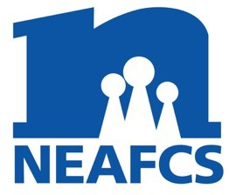
District President Annual Report
North Carolina Extension Association of Family and Consumer Sciences

District: WEST Month/Year: August 2022

District Meeting Dates & Locations:
The Fall WDEAFCS meeting was held in October in Henderson County at the Bullington Gardens where 2021-2022 officers were installed by Tracy Davis, past president. After the business meeting and educational program, members attended Renay Knapp’s retirement party, hosted at the Henderson County Center.
The Spring WDEAFCS meeting was held in Buncombe County, at the Looking Glass Creamery Business.

Educational Programs, Tours, Professional Development activities:

At the fall meeting, Administrative Director Annie Higgins provided a tour and educational program about horticulture therapy and elementary school programs at Bullington Gardens.

At the spring meeting, Cheese Store Manager Ona Courtright provided an educational program about the creation of the cheese business, how the cheeses are produced and marketing and distribution methods.
Other district activities:
The West District is welcoming many new FCS agents! We have a retreat planned this fall to provide a sense of community, educational resources and tips to avoid hard knocks.

ANNUAL REPORT SUBMITTED BY:
Margie Mansure, West District Extension Association of Family and Consumer Sciences President

